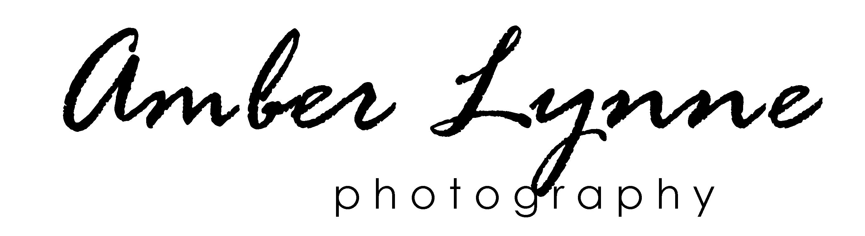

Logo Design Questionnaire
Full Name:

Email Address:

Phone Number:

Company/Organization Name:
Not many people enjoy filling out questionnaires, but for your project to be successful I need some
Not many people enjoy filling out questionnaires, but for your project to be successful I need some background information about you and your visions. Please answer these questions thoughtfully, as they will help you communicate to us what you'd like in your new logo design. Relax. It’s just 20 questions. You can do it.
Company-Related Questions
- How would you describe your services and/or products?

- What are the long term goals of your company?

- If you already have a logo, why do you want a new one? What do you want your new logo to accomplish?

- Who are your competitors? (Please provide links if possible.)

- How are your different from your competitors?

- What is the age range of your target customer base?

Project-Related Questions
- Do you have a tag line? If so, would you like it stated alongside your logo?

- Do you have any specific imagery in mind for your logo?

- Do you have any color preferences or existing brand colors?

- Do you have any colors you do not wish to use?

- What adjectives should best describe your logo?

- What feeling or message do you want your logo to convey to those who view it?

- How do you prefer your logo to be worded or written out? (example: amberlynnephoto or amber lynne photo?)

- How would you like the topography to appear? (example: script, bold, light, hand drawn…)

- Where will your logo be used? (example: print, web, t-shirts….)

- Where will your logo be primarily used?

- What is your preferred deadline, time frame, or exact date of completion?

- Budget? (Logos generally start at $200 then, depending on how complex the design, it goes up from there. Rate includes full rights (meaning you own it and can use it as you please), you will have your choice of three different logos and, once selected, up to five revisions. You will also receive three different file formats: .jpeg, .pdf, .gif. You also have the option to add on a black and white version for $20 which is great for clothing or if you are looking to save on advertisements and printed materials.)

- What logos appeal to you and why? (Feel free to attach links and visual examples.)

- Any additional details or comments you would like to share?

